**INTERNSHIP REPORT**

**Bhagalpur college of Engineering, Bhagalpur**

**Affiliated to Bihar Engineering University , Patna**

**BHAGALPUR COLLEGE OF ENGINEERING, Bihar**

**(Affiliated to BEU Patna)**



**TEAM SALESFORCE & P SINHA**

**STUDENT INTERNSHIP PROGRAM 2023 - 24**

**Bhagalpur college of Engineering,Bhagalpur**

**Affiliated to Bihar Engineering University,Patna**

**ON**

**< Salesforce Developer >**

Submitted for the purpose of the requirement for the internship

**Bachelor of Technology In**

**Computer Science and Engineering**

Submitted by

**Rajnish Kumar (D23582, 23105108914), 3rd semester**

**Under Supervision of**

**BHAGALPUR COLLEGE OF ENGINEERING,BHAGALPUR**

**(Affiliated to BEU Patna)**

I hereby declare that the work which is being presented in the report titled

**“Programming Essentials in C++”** in fulfilment of the requirement of completion of one month training in the Department of Computer Science and Engineering of **“Bhagalpur college of Engineering”** is an authentic record of my own work carried out during the training.



**DECLARATION**

We herebydeclarethattheprojectentitled**“SALESFORCEDEVELOPER”** is a genuineproject. This workhasbeensubmitted to the **BHAGALPUR COLLEGE**

**OF ENGINEERING, BHAGALPUR** permanently affiliated to **BIHAR ENGINEERING UNIVERSITY, PATNA.**

**Student’s Name** *-* **Rajnish Kumar Roll Number** – **D23582**

**Registration Number***-* **23105108914 Email id***-* [**rajnish80130***@***gmail***.***com**](mailto:roarsher261@gmail.com)

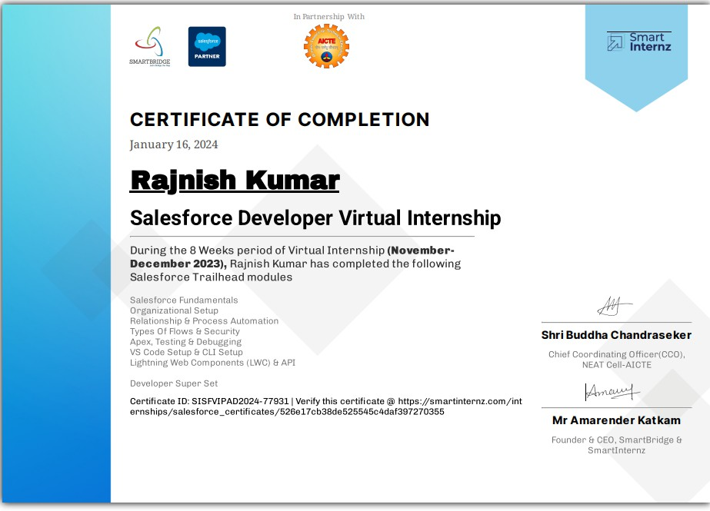

###### ACKNOWLEDGEMENT

I am profoundly grateful to **Priyaranjan Sinha** for his expert guidance and continuous encouragement throughout to see that this Internship reached its target from commencement to completion.

I express my deepest appreciation towards **Dr. O.P. Roy**, Principal, Bhagalpur College of Engineering, Bhagalpur. **Dr. Raj Anwit**, Head of the Department of Computer Engineering, whose invaluable guidance supported us in completing this Internship.

Finally, I must express our sincere heartfelt gratitude to all the staff members of the Computer Engineering Department who helped me directly or indirectly during this course of work.

**Rajnish Kumar (D23582)**

##### Abstract

During these 8 weeks of internship are total of 5 live sessions were held, I attended those live sessions through the Zoom app, The Duration of the live session is 3 hours (from 6 pm to 9 pm).

In live sessions, our mentor gave training on the given topics:

* Salesforce Org
* Relationships & Process Automation
* Types of Flows & Security
* Apex & Testing, Debugging

Lighting Web Components (LWC)There are two super badges to

be completed for completion of the internship those are mentioned below:

* Apex Specialist
* Process Automation Specialist

## INTERNSHIP PLACEMENT DETAILS

**Company Name:** Salesforce

**Address:** Mumbai, India

**Official Website:** https[://w](http://www.salesforce.com/)ww[.sale](http://www.salesforce.com/)s[force.com/](http://www.salesforce.com/)

Social Media Handles:

**a. LinkedIn:** https[://w](http://www.linkedin.com/company/salesforce/)ww[.li](http://www.linkedin.com/company/salesforce/)n[kedin.com/company/salesforce/](http://www.linkedin.com/company/salesforce/)

Company Background:

Salesforce is a global leader in customer relationship management (CRM) software, providing cloud-based solutions to businesses of all sizes and industries. With a focus on innovation and customer success, Salesforce empowers organizations to connect with their customers in new ways.

Activities:

During the internship, participants engaged in live training sessions via Zoom, covering essential Salesforce administration and development topics.

Scope:

The internship program provided hands-on experience with Salesforce Org, relationships, process automation, security, Apex, debugging, and Lightning Web Components (LWC). The scope of the internship

extended to practical application and completion of two super badges: Apex Specialist and Process Automation Specialist.

Position as an Intern:

Interns participated in a comprehensive 8-week program, attending live sessions led by experienced mentors from Salesforce. The internship focused on building practical skills and expertise in Salesforce technologies and methodologies.

Mentor(s) Name:

* Rakesh Bhoomani
* Phani Varma
* Hazari Ajay Kumar
* Tarakesh

###### Table Of Contents

|  |  |  |
| --- | --- | --- |
| **S.no.** | **Contents** | **Pg. no.** |
| 1. | Introduction | 12 |
| 2. | Suggested Prerequisites | 13 |
| 3. | Bootcamp | 14 |
| 4. | Salesforce Org | 15-21 |
| 5. | Self-Paced Learning   * Trailhead and Trailblazer Community * Salesforce Platform Basics * Platform Development Basics | 22 |

1. Relationships & Process Automation 23
2. Self-Paced Learning Modules to be completed 24-30

* Customize a Salesforce Object
* Data Modeling
* Picklist Administration
* Duplicate Management
* Formulas and Validations
* Build a Data Model for Travel Approval App
* Improve Data Quality for Recruiting App
* Customize User Interface For Recruiting App
* Lightning App Builder
  + Data Management
  + Leads and Opportunities for Lightning Experience Quick
* Start Process Builder
* Quick Start Lightning App Builder
* Automate Business Process For Recruiting App
* Build a Discount Approval Process

1. Types of Flows & Security 31-32
2. Self-Paced Learning Modules to be completed 33-36
   * Salesforce Flow
   * Flow Builder
   * Data Security
   * Keep Data Secure In Recruiting App
3. Apex & Testing, Debugging 37
4. Self-Paced Learning Modules to be completed 38-39
   * Apex Triggers
   * Apex Testing
   * Asynchronous Apex
5. Lightning Web Components (LWC) 40-42
6. Self-Paced Learning Modules to be completed 43-45
   * VS Code Setup
   * CLI Setup
7. Lightning Web Components (LWC & API) 46-47
8. Self-Paced Learning Modules to be Completed 48-49
   * API Basics
   * Event Monitoring
   * Shield Platform
   * Integration Services
9. Project / Super Badges 50-52
   * Apex Specialist
   * Process Automation Specialist
   * Process Automation Specialist
10. Executive Summary 53
11. About The Company 54
12. Opportunities 55
13. Training 56
14. Challenges Faced 57

### CHAPTER 1: Introduction

Salesforce is the **CRM** (Customer Relationship Management) where it unites Marketing, Sales, Commerce, IT etc. teams to their customers to deliver a better service. We are determined to teach this emerging Technology in a very realistic and fun way. We have organized the challenges in such a way that the learner will be able to learn salesforce in a very enthusiastic and fun way with a limited time participation. This program consists of live sessions, Hands-on practical activities, Mentoring support and working on super badges on Trailhead platform. In order to help all beginners understand the salesforce ecosystem and its products, we have curated a few best modules on the trailhead platform that will help you to get ready for the Bootcamp.

# CHAPTER 2: Suggested Prerequisites

This section is to provide thecandidatesa quick look at the salesforce environment. Though thissection is not mandatory, wehighly recommendthe candidatesto go through thebelowmentioned modules. You will be very well acquaintedwiththeplatformandalso withtheusage of Trailhead fromthevery beginning. (Recommended for beginners).

* + Salesforce user basics
  + Salesforce quick look
  + Salesforce CRM
  + Salesforce Platform For Business Users
  + Salesforce User Tour
  + Salesforce Licensing
  + Lightning Experience Basics
  + Salesforce Customer 360: Quick Look
  + The fourth Industrial Revolution: Quicklook
  + Salesforce Developercareer Path
  + Trailhead and TrailblazerCommunity

**CHAPTER 3: Bootcamp**

Bootcampwill be organizedfor3 weekswhere 2 Live Sessionswill beconducted perweekwith 3 Hours persession. Learners need to complete theself- paced courses on Trailheadplatformparallely along withtheboot camps. The Day wise content andreferencesto complete trailhead modulesaregiven.

CHAPTER 4: Salesforce Org

A Salesforce org is an entity which consists of the users, data, automation corresponding to an individual organization. An organization could be a virtual space given to a person client of Salesforce. Your organization incorporates all of your information and applications, and is isolated from all other organizations.

ASalesforceOrgconsistsof:

* Introduction to Salesforce
* What is Salesforce CRM?
* Setup a free developer account in Salesforce?
* Architecture of Salesforce
* Creating a FREE Salesforce Org
* Navigating the Salesforce User Interface
* Lightning vsClassic Salesforce Interface
* Salesforce Branding and UI Customization
* Density Settings
* User Navigation Bar Customization
* Salesforce Themes and Branding
* Company Profile
* User Management
* Organizational & UserSetup

##### Introduction to Salesforce:

A global web-based software and cloud computing company best known for its customer relationship management (CRM) product. Salesforce was founded by former executive of Oracle Marc Benioff and Parker Harris in 1999 and specialises in software as a service (SaaS) to help users handle all of their business needs like managing marketing campaigns, analysing performances, and tracking spending and sales.

##### What is Salesforce CRM?

Customer relationship management (CRM) is **a technology for managing all your company's relationships and interactions with customers and potential customers**. The goal is simple: Improve business relationships. A CRM system helps companies stay connected to customers, streamline processes, and improve profitability.

Setupa free developer account in Salesforce?

1. Go to [http://developer.salesforce.com](http://developer.salesforce.com/)

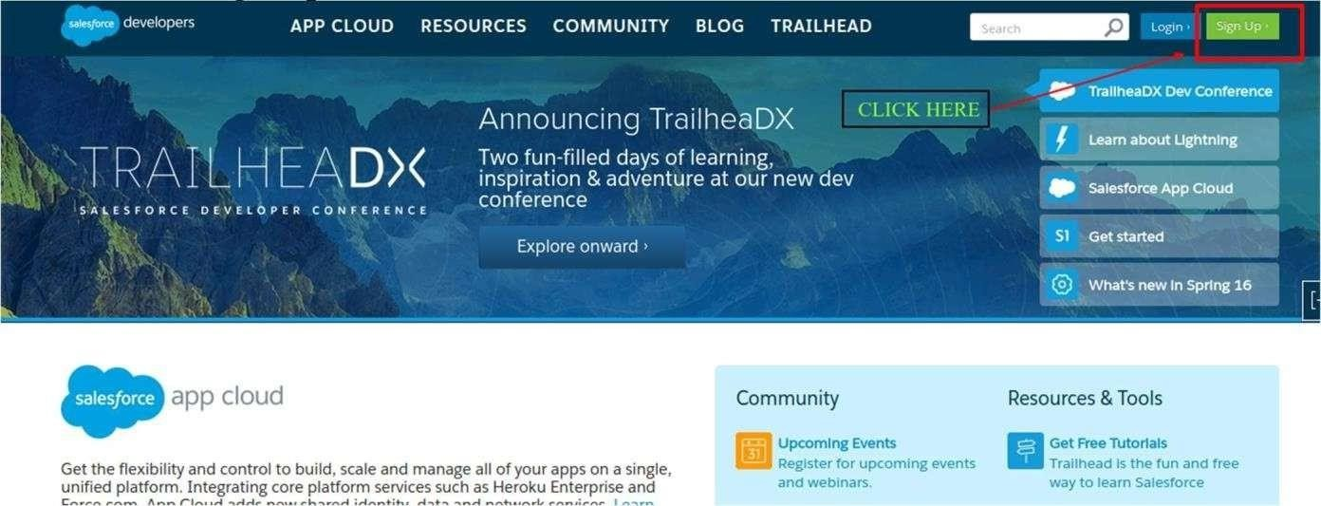

1. Now click **Sign Up**
2. Fill all detailswithvalid **Email Address**.

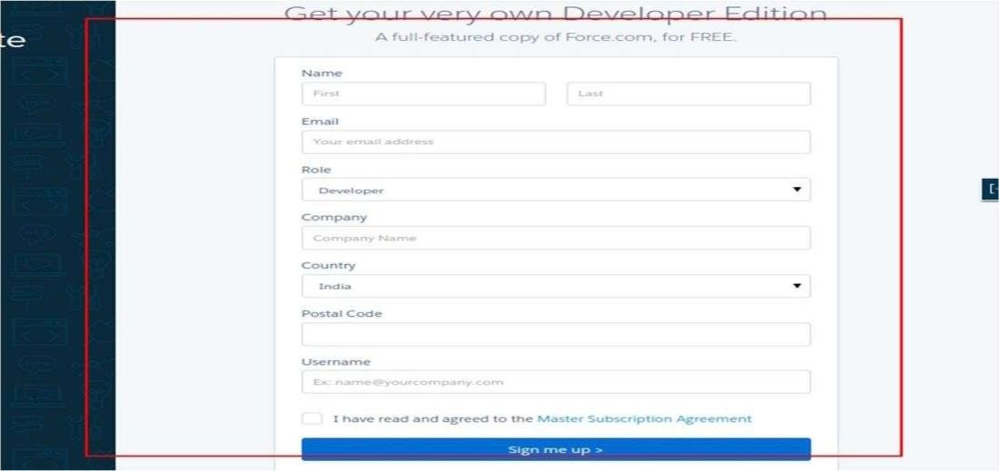

1. An Emailwill be sent to yourEmail Address.
2. Now click thelinkprovided in Email.
3. Setyour passwordto your account.
4. Now youareable to login withsalesforce developeraccount.
5. Go to https://login.salesforce.com.
6. Enter yourUsername and Password click on Login.

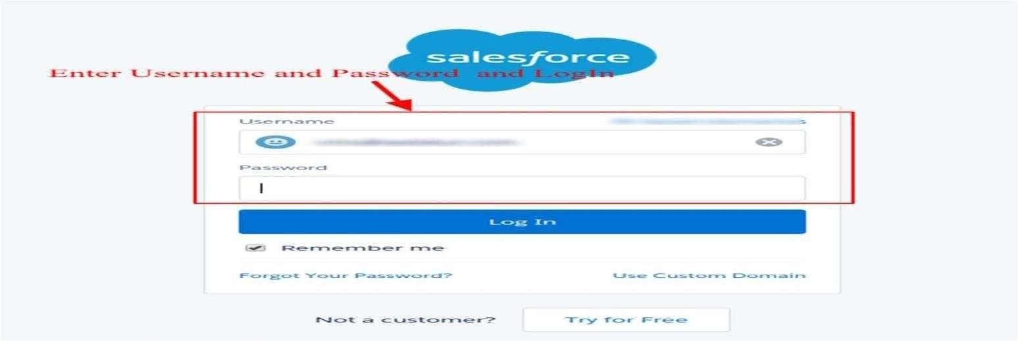

1. Nowyouare on Salesforce.comHomepage.

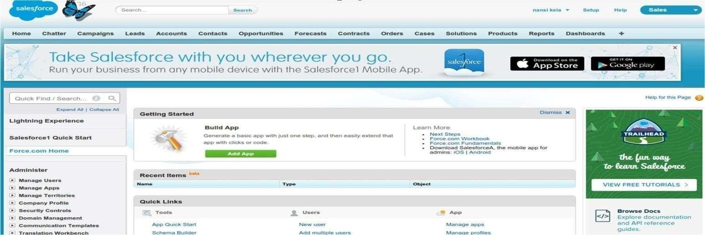

Architecture of Salesforce:

Salesforce Architecture is themultilayerarchitecture; itcontains aseries of layers situatedon thetop of eachother.

The below diagramshows thearchitecturalview of thesalesforce:

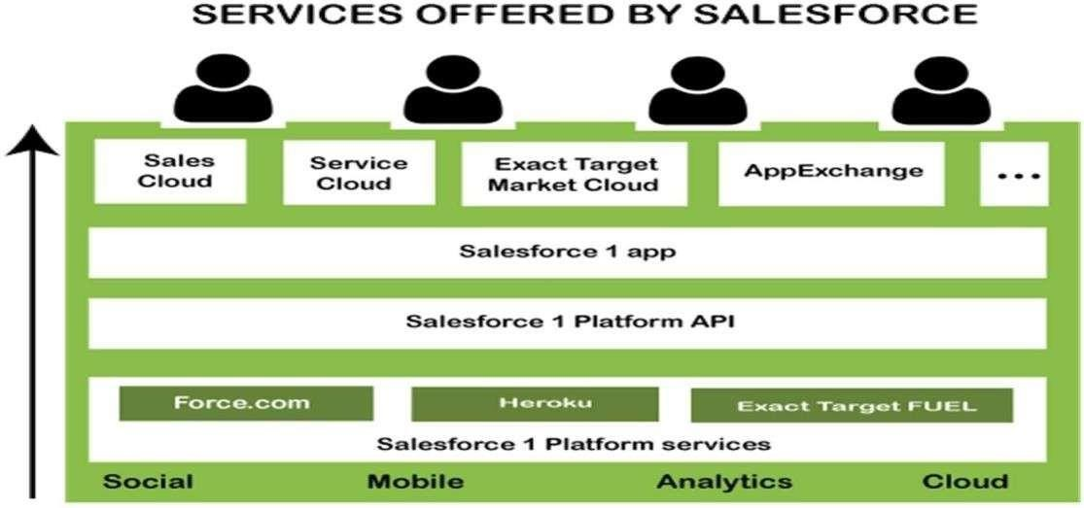

Creating a FREE Salesforce Org:

1. Log into the Environment Hub, and then select **Create Org**.
2. Choose an org purpose.
   * **Development**: Use Developer Edition orgs for packaging and building apps.
   * **Test/Demo**: We can create Test/Demo versions of standard Salesforce orgs with the help of [www.salesforce.com/trial](http://www.salesforce.com/trial).
3. Enter the required information for the org type you selected.
4. Read the **Master Subscription Agreement**, and then select the checkbox.
5. Select **Create**.

At last, when your org is ready, you may receive a confirmation message in your email.

Navigating the Salesforce User Interface:

The navigation bar in **Lightning Experience** provides an efficient and consistent interface to navigate through your organization’s various apps and items. Similar to Salesforce Classic, apps in Lightning Experience give your users access to sets of objects, tabs, and other items all in one convenient bundle in the navigation bar. However, apps in Lightning Experience take things to another level beyond apps in Salesforce Classic by letting you brand your apps with a custom color and logo. In Lightning Experience, you can even include Lightning page tabs and a utility bar that allows instant access to productivity tools, like integrated voice, in the footer of Lightning Experience.

Lightning vs Classic Salesforce Interface:

Salesforce Lightning has a new and improved interface whereas Classic sticks to the tried- and- trusted Salesforce formula. Lightning also comes with improved features such as an activity timelineandworkplacepage layouts.

Salesforce Branding and UI Customization:

**Salesforce Branding**

Rally your team around your brand and important initiatives, like a new product launch, with a set of custom brand images and colors in your org. We call them themes. You can choose one of the built-in Salesforce themes, or create your own customthemeswithjustafewclicks.

UI Customization:

The improved Setup user interface provides a streamlined experience for viewing and managing personal and administrative setup tasks. Easily remove the Salesforce NotificationBannerforall users inyour organization.

Density Settings:

To change the Densitysetting, click on yourusername in the toprightcorner of the page andchoose “Comfy”or “Compact” under theDisplay Densitysection.

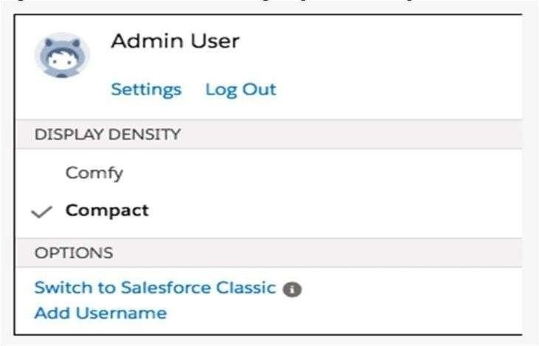

User Navigation Bar Customization:

To add items to your navigation bar, click Add More Items. Search through your favorites or all available items in your org, and choose what to add. After you make your selections, you can reorder or remove items before saving your changes. You can'trenameorremoveitemsthatyour adminhasspecifiedfor theapp.

Salesforce Themesand Branding:

**Salesforce Themes:**

Rally your team around your brand and important initiatives, like a new product launch, with **a set of custom brand images and colors in your org**. We call them themes.

Branding Components:

A strong brand requires a strong **brand identity, brand image, brand culture, and brand personality**. Implementing a successful brand strategy that develops all four of thesecomponentsincreasesbrandtrust,loyalty,andawareness.

User Management:

A user is anyone who logs in to Salesforce. Users are employees in your organization. Every user in Salesforce has a user account. The user account identifies the user, and the account settingsdeterminewhat featuresandrecordsthe usercanaccess.

### CHAPTER 5: Self-Paced Learning

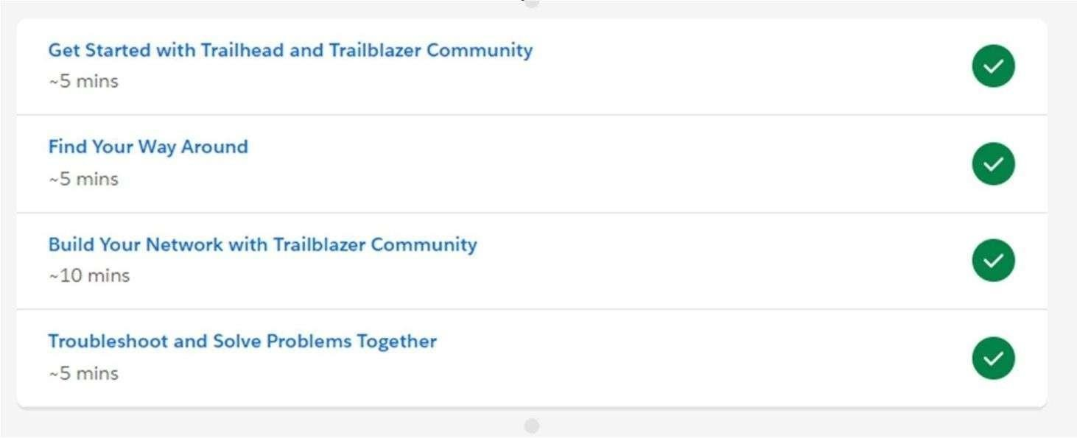Trailheadand Trailblazer Community:

SalesforcePlatform Basics:

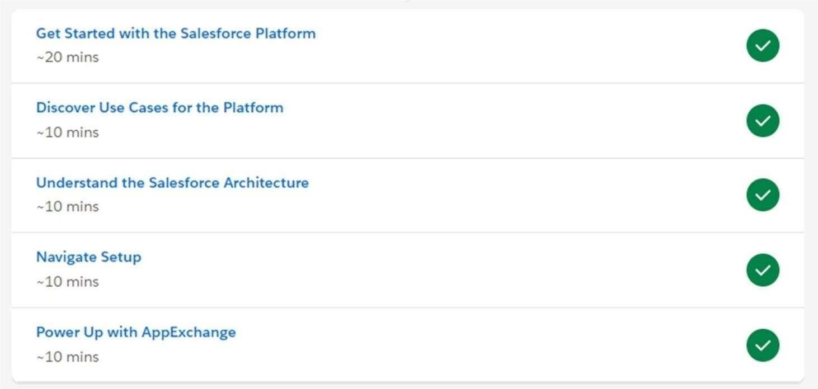

Platform Development Basics

Salesforce Platform is the app development platform that extends your CRM's reach and functionality. You do not have to be a developer to build apps using the Salesforce Platform.

### CHAPTER 6: Relationships & Process

**Automation**

**Process automation** uses technology to automate complex business processes. It typically has three functions: automating processes, centralizing information, and reducing the requirement for input from people. It is designed to remove bottlenecks, reduce errors and loss of data, all while increasing transparency, communication across departments,andspeedof processing.

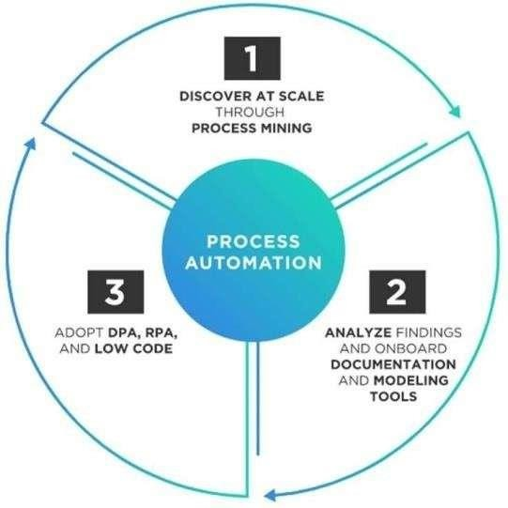

Relationships & Process Automation consists of:

1. Object Relationships
2. Process automation overview
3. Workflow Rules & Actions
4. Validation Rules
5. Approval Processes
6. Process Builder Overview
7. Creating a Process Builder Process
8. Process Builder Actions
9. Process Builder in Practice

### CHAPTER 7: Self-Paced Learning Modules to

**be completed**

Customize a Salesforce Object

To createcustomobjectinSalesforce, performthefollowingsteps:

* 1. Log in toyourSalesforceaccount.
  2. Click **Setup**atthe upper-right corner.
  3. Underthe**Build**section, click **Create** andselect **Objects**.
  4. To createa customobject,click **NewCustomObject**.

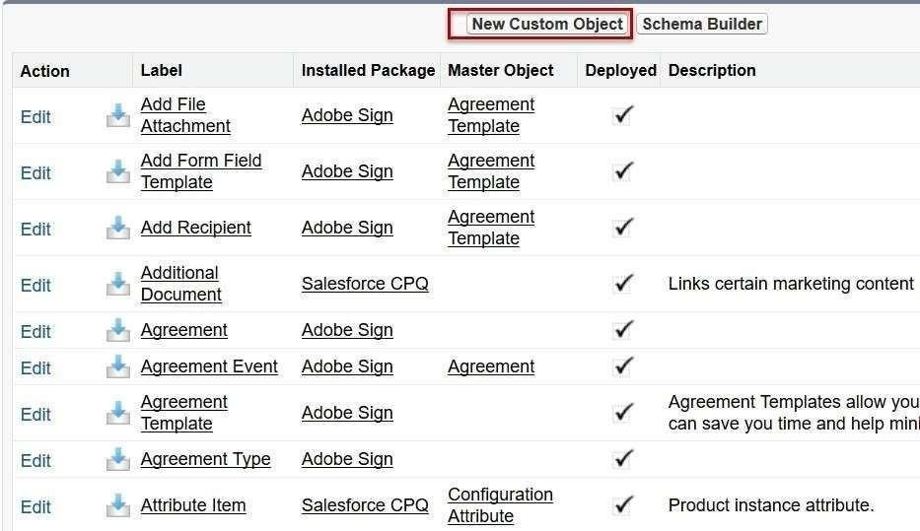

* 1. Enter the name of the Custom Object in **Label**, **Plural Label**, and **Object Name**

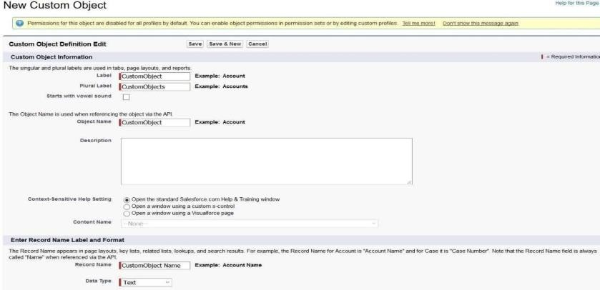

* 1. Select the Launch **New Custom Tab Wizard after saving this custom object** check box and **click Save**.

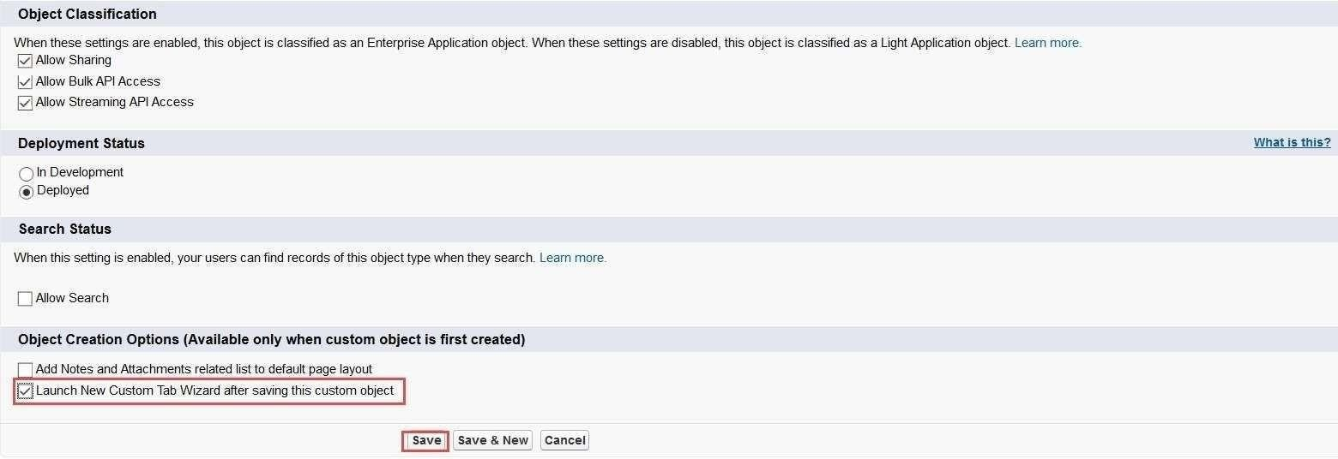

* 1. To select an icon for the tab, click the **Search** icon and click **Save**.

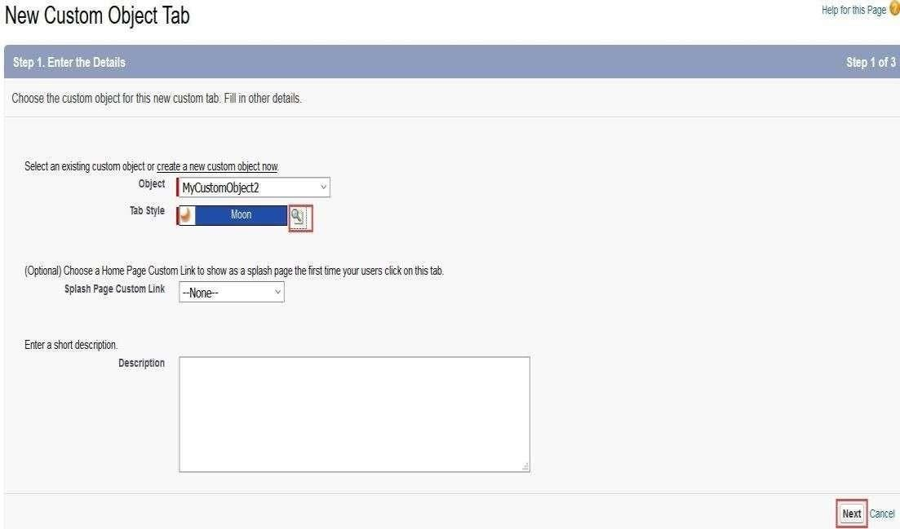

* 1. To make the Custom Object available to Profiles, select the appropriate option and click **Next**.

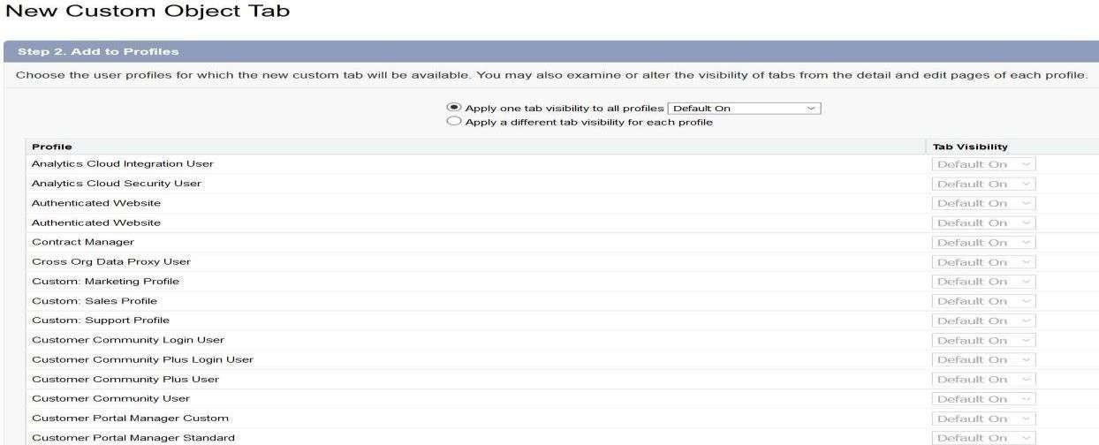

* 1. Choose the custom apps for which the new Custom tab is required and click **Save**.

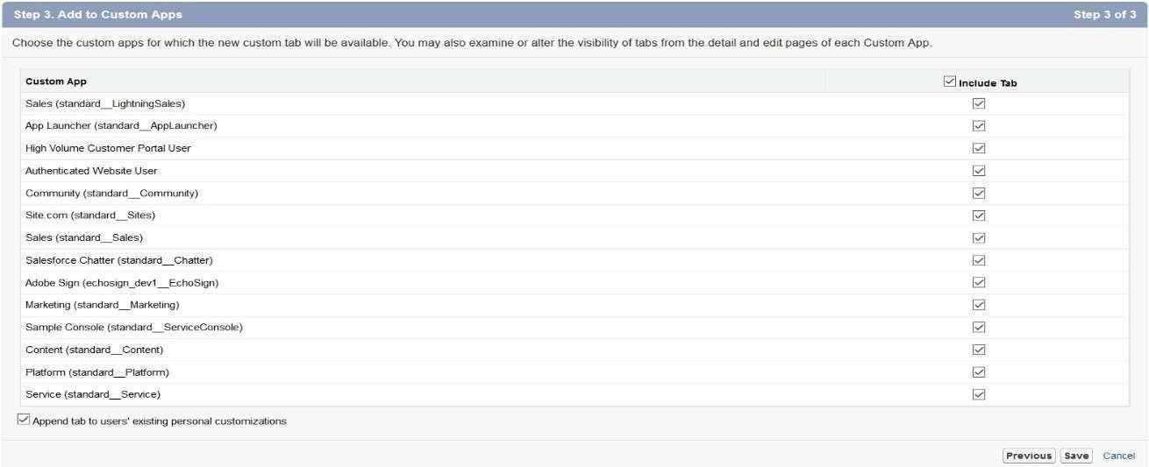

Data Modeling

Data modeling is the process of analyzing and defining all the different data your business collects and produces, as well as the relationships between those bits of data. Data modeling concepts create visual representations of data as it’s used at yourbusiness, and the process itself is an exercise in understandingandclarifying your datarequirements.

Picklist Administration

Picklist helps with data entry and standardizing input values. Picklist guides the user to values they need and makes data entry quicker. The picklist is not ideal for long entries or valuesthatarenotunique.

Types of Picklists in Salesforce:

Therearethreetypes of picklist usedinsalesforce:

▶ Standard

▶ Custom

▶ Custom Multi-Select

Properties of Picklist:

▶ Restricted

▶ Dependent

Values in Salesforce Picklist

In salesforce value can be defined in three ways:

▶ When we create a picklist we need to set individual values (specific to a single picklist field) .

▶ We can use a predefined picklist which is a standard picklist field by salesforce.com.

▶ Create a global value set. When we need to share with more than one picklist field, we can set a global value set.

Duplicate Management

Salesforce finds and handles duplicates using a combination of matching rules and duplicate rules. Duplicate rules and duplicate jobs specify matching rules that determine how duplicates are identified. Duplicate sets and reports list the duplicates found.

Formulas and Validations

A validation rule can contain a formula or expression that evaluates the data in one or more fields and returns a value of “True” or “False”. Validation rules also include an error message to display to the user when the rule returns a value of “True” due to an invalid value.

Builda Data Model for Travel Approval App

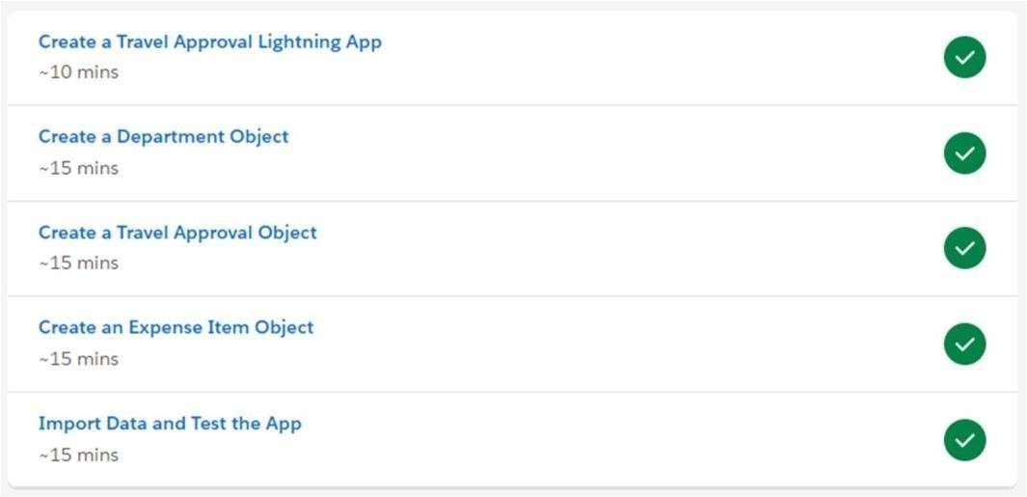

**Improve Data Quality for a Recruiting App**

We can improve data quality for a recruiting app by:

1. Creating cross-object formulas.
2. Creating validation rules.
3. Creating formula and roll-up summary fields.

Customize User Interface for Recruiting App

To customize the User Interface for a Recruiting App:

1. Create a Tab for the Review Object.
2. Create an Object-Specific Quick Action.
3. Customize the Review Page Layout.
4. Create a Custom Candidate Record Page.
5. Create Record Types on the Position Object.
6. Customize the Position Page Layout.
7. Enable Chatter on the Review Object.

Lightning App Builder

The Lightning App Builder is a point-and-click tool that makes it easy to create custom pages for the Salesforce mobile app and Lightning Experience, giving your users what they need all in one place. The Lightning App Builder is also a one-stop shop for configuring Lightning apps.

Data Management

Data management in Salesforce involves the import/export of data or records to/from a Salesforce organization.

* + **Data Import Wizard**: The Data Import Wizard simplifies the process of importing data for many standard Salesforce objects, including accounts, contacts, leads, solutions, campaign members, and person accounts. It also supports importing data for custom objects, with a limit of up to 50,000 records at a time.
  + **Data Export in Salesforce**: Salesforce Data Export Service is a function that allows you to export data from your Salesforce org for backup purposes. You can export all your data either manually or automatically through scheduled export.

Leads and Opportunities for Lightning Experience

1. Create and Convert Leads as Potential Customers.
2. Work Your Opportunities.
3. Sell as a Team and Split the Credit.
4. Visualize Success with Path and Kanban.

Quick Start Process Builder

Process Builder is a visual tool designed to automate business processes in Salesforce. It enables users with no coding expertise to build complex Salesforce workflows. The book starts with an introduction to Process Builder, focusing on the building blocks of creating Processes.

Quick Start Lightning App Builder

Add Quick Actions and Configure the Page:

1. In the right sidebar, click **Page** to configure the app properties.
2. At the bottom, click **Select** under **Actions**.
3. Click **Log a Call** and use the right arrow to add the quick action to the selected list.
4. Click **OK** to add the actions to your Lightning Page, and then click **Save**.

Automate Business Process for Recruiting App

Automate Your Business Process:

1. Click the setup gear and select **Setup**.
2. Enter **Queues** in the Quick Find box, then select **Queues**.
3. Click **New** and complete the details about the new queue:
   * **Field**: Value
   * **Label**: Billing Support Agents
4. From the **Available Objects** list, select **Case**.
5. Click **Add** to move **Case** to the **Selected Objects** list.

Build a Discount Approval Process

Steps to Build a Discount Approval Process:

1. **Prepare Your Org.**
2. **Create an Approval Process.**
3. **Create Initial Submission Actions.**
4. **Specify Final Approval and Rejection Actions.**

# CHAPTER 8: Types of Flows & Security

###### Types of Flow:

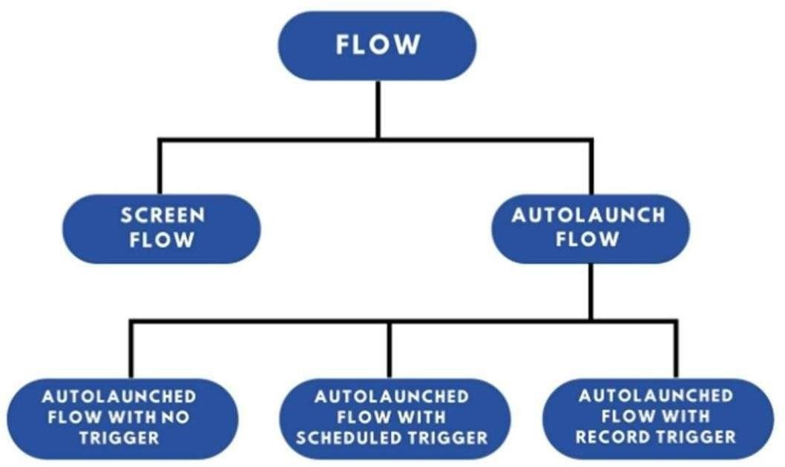

Flow Security

* + **Granting Access:** If guest or external users need to run flows, override the flow permission to grant access only to specific external user profiles, permission sets, or site guest user profiles, rather than allowing all users to run all flows. Avoid running flows in system context when possible, and restrict access to sub-flows. If it’s unavoidable, ensure that you implement procedural access controls for those flows and sub-flows.
  + **Flow Permissions:** Flows are a powerful feature that can override platform security settings for access to objects and Apex classes. Flows can also be used to activate and deactivate permission sets. However, screen flows are driven by the browser with user-controlled input parameters. It is recommended to override the run flow permission to assign access to specific flows based on the guest or external

user profile or permission set. For guest users, configure flow access policies on the guest user profile for the appropriate site.

* + **Best Security Practices:** It is a good security practice to remove permissions to run sub-flows, even if users run the sub-flow independently. From a security

perspective, it’s better to create two separate flows and give access only to the flow that the user runs directly, not the one running as a sub-flow. Grant flow access only to the highest-level parent flow and not to the sub-flows.

* + **Apex Methods:** The same security recommendation applies to invocable Apex methods called by flows. Avoid granting user access to those classes so that calling those methods is limited to only the flows that they were intended to be called from.

### CHAPTER 9: Self-Paced Learning Modules to be

**Completed**

Salesforce Flow

A flow is an application built by your administrator that asks for inputs and performs actions in Salesforce based on those inputs. It's important to monitor flows and processes to track your organization's usage. You can see a list of paused interviews and scheduled actions from processes.

Flow Builder

Flow Builder is the declarative interface used in Salesforce to build individual flows. It is a tool that automates complex business processes by collecting data and performing specific actions with that data. Flow Builder allows for the creation of code-like logic without requiring a programming language.

Categories of Flows:

1. Screen Flows:
   * These flows include a user interface (UI) element and require input from users.
   * They can be launched as an action or embedded as an element on a Lightning page.
2. Schedule-Triggered Flows:
   * These auto-launched flows are scheduled to run at a specific time and frequency for each record in a batch.
   * They operate in the background.
3. Auto-Launched Flows:
   * Used for running automated tasks.
   * Auto-launched flows can be invoked from other flows (sub-flows), Process Builder, Apex classes, schedules, record changes, or platform events.
4. Record-Triggered Flows:
   * These flows run in the background when a record is created, updated, or deleted.
   * They can be triggered either before a record is saved or after the save.
5. Platform Event-Triggered Flows:
   * These auto-launched flows are triggered when a platform event message is received, running in the background.

Example: Check out this example of a schedule-triggered flow, pulled from a well-known Salesforce group.

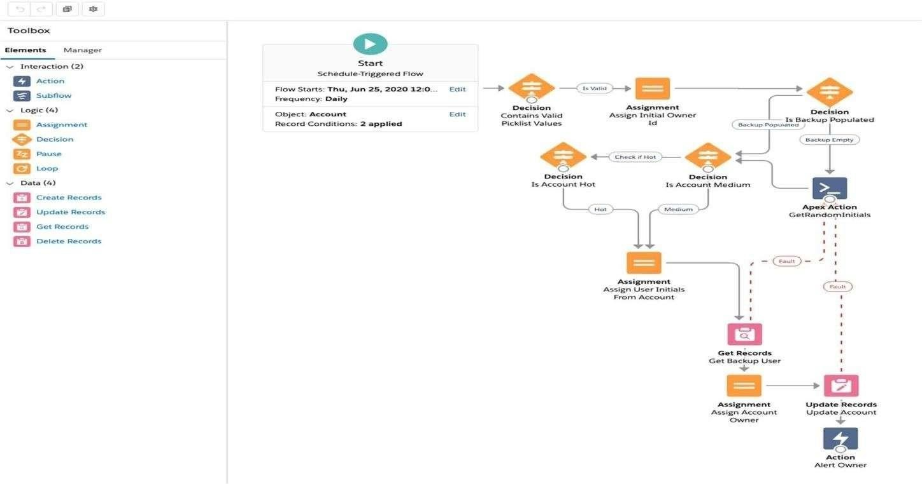

Data Security:

Salesforce data access is configured at four levels:

1. **Organization Level**:
   * Access to the entire organization is secured at this level.
   * Security measures include maintaining a list of authorized users, setting password policies, and restricting login access to specific hours and locations.
2. **Object Level**:
   * Object-level security controls which users have access to specific data types.
   * Permissions can be set to prevent certain groups of users from creating, viewing, editing, or deleting records of a particular object.
3. **Field Level**:
   * Field-level security restricts access to specific fields within objects.
   * Even if a user has access to an object, their ability to view or edit certain fields can be limited.
4. **Record Level**:
   * Record-level security allows for more precise control of data access.
   * Users can be granted access to view an object while being restricted from viewing or editing individual records within that object.

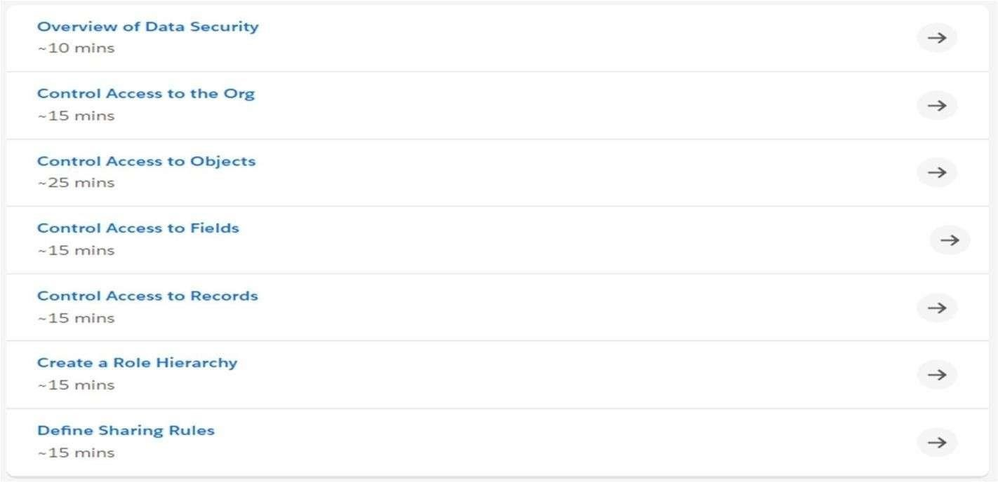

Keep Data Secure in Recruiting App

To ensure data security in a recruiting app, you can follow these steps:

1. **Create Custom Profiles**:
   * Develop custom profiles tailored to different user roles, ensuring that each user has access only to the necessary data and functions.
2. **Restrict Data Access with Field-Level Security, Permission Sets, and Sharing Settings**:
   * Implement field-level security to limit access to sensitive information.
   * Use permission sets to grant additional access as needed, without altering profiles.
   * Configure sharing settings to control which records users can view or edit, maintaining strict data confidentiality.

### CHAPTER 10: Apex & Testing, Debugging

Debugging Apex:

* Apex provides debugging support through tools like the Developer Console and debug logs, which help you troubleshoot your code effectively.

Testing Apex:

* Apex includes a testing framework that enables you to write unit tests, run them, check the results, and monitor code coverage.

In this section, we cover the following topics:

* What is Apex?
* Apex Data Types
* SOQL (Salesforce Object Query Language)
* SOSL (Salesforce Object Search Language)
* Triggers
* Testing Deployment Requirements and Testing Framework
* Writing Apex Unit Tests
* Test Data
* Executing Test Classes
* Invoking Apex in Execute Anonymous vs. Unit Tests
* Monitoring and Accessing Debug Logs

##### CHAPTER 11: Self-Paced Learning Modules to be completed

Apex Triggers

* Apex triggers allow you to perform custom actions before or after changes to Salesforce records, such as insertions, updates, or deletions.
* A trigger is Apex code that executes before or after the following types of operations:
  + insert
  + update
  + delete
  + merge
  + undelete

Apex Testing

* Apex provides a testing framework that allows you to write unit tests, run tests, check results, and monitor code coverage. Let's dive into some key aspects of Apex testing:
  + Understanding Testing in Apex
  + What to Test in Apex
  + What Are Apex Unit Tests?
  + Understanding Test Data
    - Apex test data is transient and isn’t committed to the database.
  + Run Unit Test Methods
    - To verify the functionality of your Apex code, execute unit tests using the Developer Console, Setup, Salesforce extensions for Visual Studio Code, or the API.
  + Testing Best Practices
  + Testing Example
  + Testing and Code Coverage
    - The Apex testing framework generates code coverage numbers for your classes and triggers every time you run tests. Code coverage measures

how many executable lines of code have been exercised by test methods.

* + Code Coverage Best Practices
    - Consider the following tips and best practices for achieving optimal code coverage:
    - Build a Mocking Framework with the Stub API:
      * Apex provides a stub API for creating a mocking framework, which has many benefits, such as streamlining testing and improving reliability. This is crucial for unit testing, as it allows for testing classes in isolation. Stub objects are generated at runtime, eliminating the need to package and deploy test classes.

Asynchronous Apex

* Asynchronous Apex is used to run processes in a separate thread, at a later time. This allows tasks to be executed "in the background," so the user does not have to wait for the task to finish.
* Asynchronous Apex comes in several forms, each serving different purposes, which will be explored in more detail.

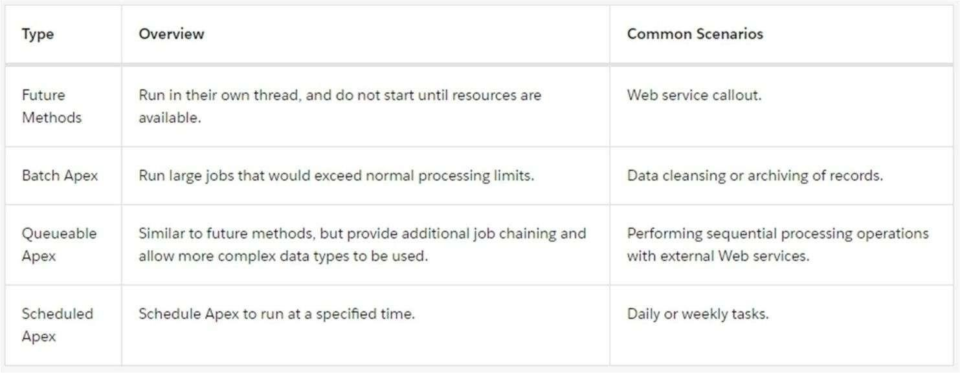

**CHAPTER 12: Lighting Web Components**

## (LWC)

Now you can build Lightning components using two programming models: Lightning Web Components, and the original model, Aura Components. Lightning web components are custom HTML elements built using HTML and modern JavaScript.

Lightning web components and Aura components can coexist and interoperate on a page. To admins and end users, they both appear as Lightning components.

Lightning Web Components uses core Web Components standards and provides only what’s necessary to perform well in browsers supported by Salesforce. Because it’s built on code that runs natively in browsers, Lightning Web Components is lightweight and delivers exceptional performance. Most of the code you write is standard JavaScript and HTML.

Salesforce is committed to developing open web standards and is a member of the World Wide Web Consortium (W3C).

Salesforce developers are contributing members of the ECMA International Technical Committee 39 (TC39), which is the committee that evolves JavaScript.

Base Lightning components are available as Aura components and as Lightning web components. The Component Reference includes documentation, specifications, and examples for both. See Base Components: Aura Vs Lightning Web Components for differences between them.

Documentation Changelog

This page lists significant changes made to the Lightning Web Components Developer Guide.

Get Started Coding

The fastest way to code your first Lightning web component is in the third-party component IDE at webcomponents.dev.

Lightning Web Components: Open Source

Lightning Web Components is open source, empowering you to explore the source code, customize the behavior for your needs, and build enterprise-ready web components on any platform, not just Salesforce.

Supported Browsers

Lightning Web Components supports the same browsers as Lightning Experience.

Supported JavaScript

To develop Lightning web components, use the latest versions of JavaScript.

Supported Salesforce Targets and Tools

Lightning web components are supported in many Salesforce targets and tools. To use a Lightning web component in an unsupported target or tool, wrap it in an Aura component.

Lightning Component Library

The Lightning Component Library is your hub for Lightning UI developer information, including reference information, this developer guide, and tools for Lightning Web Security and Lightning Locker.

How to Choose Lightning Web Components or Aura

Lightning web components perform better and are easier to develop than Aura components. However, when you develop Lightning web components, you also may need to use Aura, because LWC doesn’t yet support everything that Aura does.

Set Up Your Development Environment

Develop Lightning web components with a workflow that fits your needs. We recommend Salesforce DX tools, but you might be in a situation where those tools are not supported. You can still use your favorite code editor and deploy to an org using your own tools. However, you can’t develop Lightning web components in the Developer Console.

Explore Trailhead and Sample Code

We’ve created Trailhead content and GitHub repositories to jump start your Lightning Web Components development**.**

### CHAPTER 13: Self-Paced Learning Modules to be

**completed**

VS Code Setup:

Install Salesforce Extensions for Visual Studio Code

Visual Studio Code is the go-to code editor for Salesforce developers. It's free, open-source, and available for Windows, Linux, and mac OS. This editor has easy-to-install extensions for syntax highlighting, code completion, and more. Visual Studio Code's code completion in action.

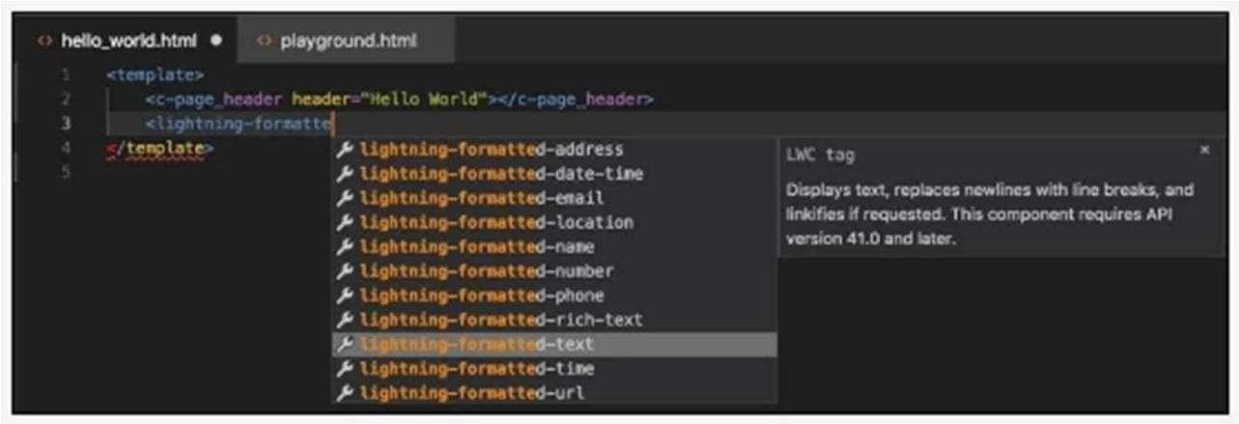

In this project, we install Visual Studio Code and the recommended Salesforce Extension Pack.

1. Download and install the latest version of Visual Studio Code for your operating system.

If you already have Visual Studio Code installed, there's no need to reinstall it.

1. Launch Visual Studio Code.
2. On the left toolbar, click the Extensions icon
3. Search for Salesforce Extension Pack and click Install.

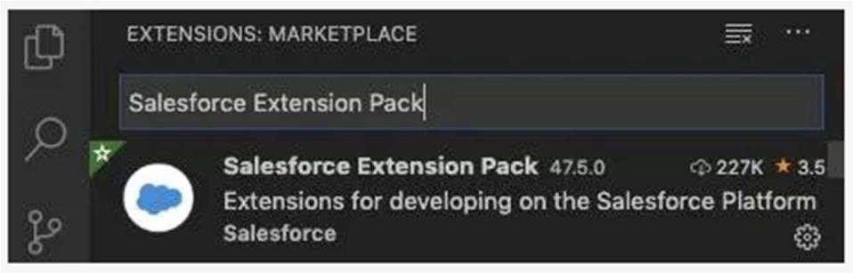

1. Ensure Your Development Environment Is Ready
2. Now that you've installed Visual Studio Code and enabled the necessary extensions, you need to test them out.
3. In Visual Studio Code, open the Command Palette by pressing Ctrl+Shift+P (Windows) or Cmd+Shift+P (macOS).
4. Enter sfdx to filter for commands provided by the Salesforce Extensions.v

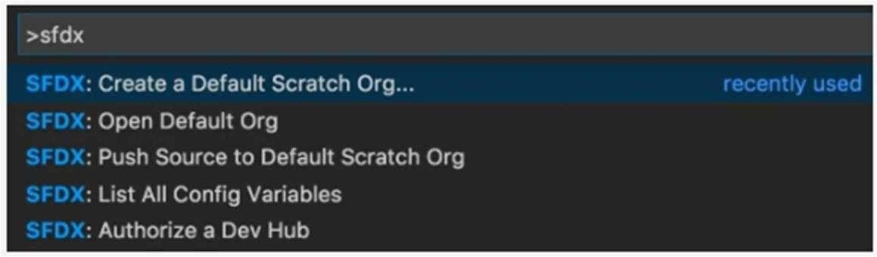

As you use more SFDX commands, those commands will show up in the recently used panel. In the final step, you create your first Lightning web component and add it to yourorg'shomepage.

CLI Setup

Install the CLI on your computer using operating system-specific artifacts, such as . pkg on macOS, or with npm.

Methods of installation:

Install the CLI on macOS

You install Salesforce CLI on macOS with a .pkg file.

Install the CLI on Windows

Install Salesforce CLI on Windows with an .exe file.

Install the CLI with a TAR File

Salesforce CLI distributes TAR files that you can install on all supported operating system. On Linux, the only way to install Salesforce CLI is with a TAR file.

Install the CLI with npm

If you've installed Node.js on your computer, you can use npm to install Salesforce CLI. This method lets you install Salesforce CLI from the command line and can be especially useful for continuous integration (CI) use cases.

Install Older Versions of Salesforce CLI

We recommend that you always use the latest version or release candidate of Salesforce CLI. However, we also understand that sometimes you might require an older version of the CLI. For these use cases, we publish JSON files that list the download URLs for recent versions of the installers and TAR files for each supported operating system.

Verify Your Installation

Verify your Salesforce CLI installation to ensure you’ve installed it correctly.

##### CHAPTER 14: Lightning Web Components (LWC & API)

Web API Properties

Lightning web components reflect the properties of many Web APIs.

Element

Lightning web components reflect these properties of the Element interface. classList,className,getAttribute, getAttributeNS,getBoundingClientRect, getElementsByClassName, getElementsByTagName, hasAttribute, id, querySelector, querySelectorAll, removeAttribute, removeAttributeNS, setAttributeNS, setAttribute, shadowRoot, slot See Shadow DOM, Access Elements the Component Owns, and Pass Markup into Slots. When Lightning Web Security is enabled in the Salesforce org, setAttributeNS, setAttribute, and shadowRoot are modified by distortions.

EventTarget

Lightning web components reflect these properties of the EventTarget interface. addEventListener, dispatchEvent, removeEventListener See Communicate with Events.

HTML Element

Lightning web components reflect these properties of the HTMLElement interface. accessKeyLabel, contentEditable, dataset, dir, hidden, isContentEditable, lang, offsetHeight, offsetLeft, offsetParent, offsetTop, offsetWidth, title When Lightning Web Security is enabled in the Salesforce org, dataset is modified by a distortion.

Node

Lightning web components reflect this property of the Node interface.

isConnected

See Run Code When a Component Is Inserted or Removed from the DOM.

WAI-ARIA States and Properties

Lightning web components reflect these WAI-ARIA states and properties. ariaActiveDescendant,ariaAtomic,ariaAutoComplete,ariaBusy,ariaChecked, ariaColCount, ariaColIndex, ariaColSpan, ariaControls, ariaCurrent, ariaDescribedBy See Component Accessibility.

### CHAPTER 15: Self-Paced Learning Modules to be

**completed**

**API Basics:**

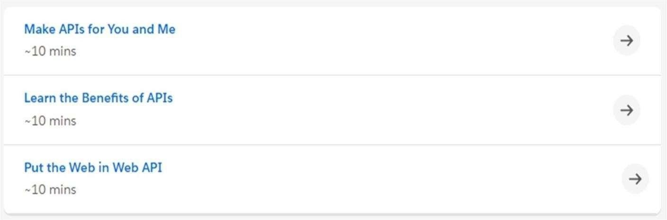

Event Monitoring:

These examples use REST API event monitoring data that contains information useful for assessing org usage trends and user behavior. Event monitoring is accessed through the Lightning Platform SOAP API and REST API by way of the EventLogFile object. Therefore, you can integrate log data with your own back-end storage and data marts to correlate data from multiple orgs and across disparate systems.

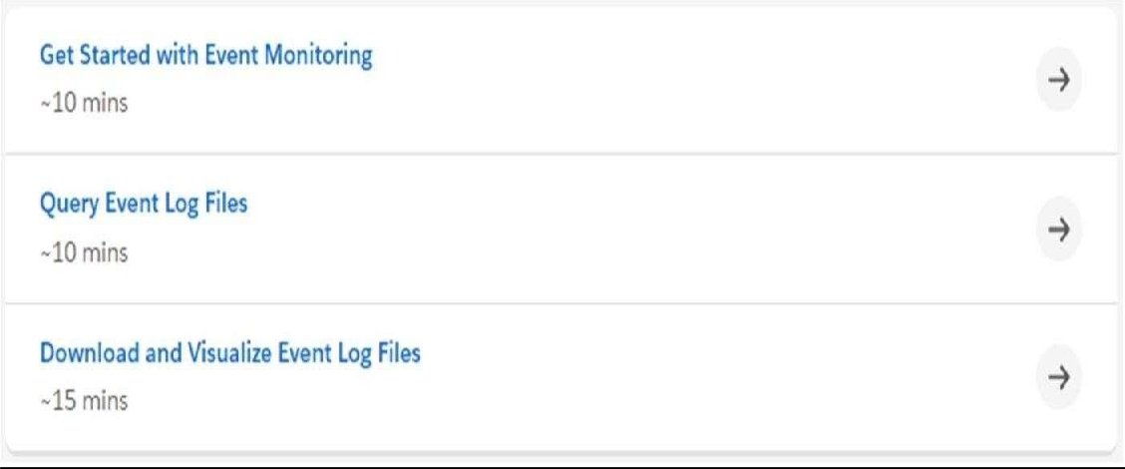

Shield Platform Encryption Shield:

Shield Platform Encryption relies on a unique tenant secret that you control and a master secret that's maintained by Salesforce. By default, we combine these secrets to create your unique data encryption key. You can also supply your own final data encryption key. We use your data encryption key to encrypt data that your users put into Salesforce, and to decrypt data when your authorized users need it.

Shield Platform Encryption Terminology:

Encryption has its own specialized vocabulary. To get the most out of your Shield Platform Encryption features, it’s a good idea to familiarize yourself with key terminology.

Apex Integration Services

An Apex callout enables you to tightly integrate your Apex code with an external service. The callout makes a call to an external web service or sends an HTTP request from Apex code, and then receives the response.

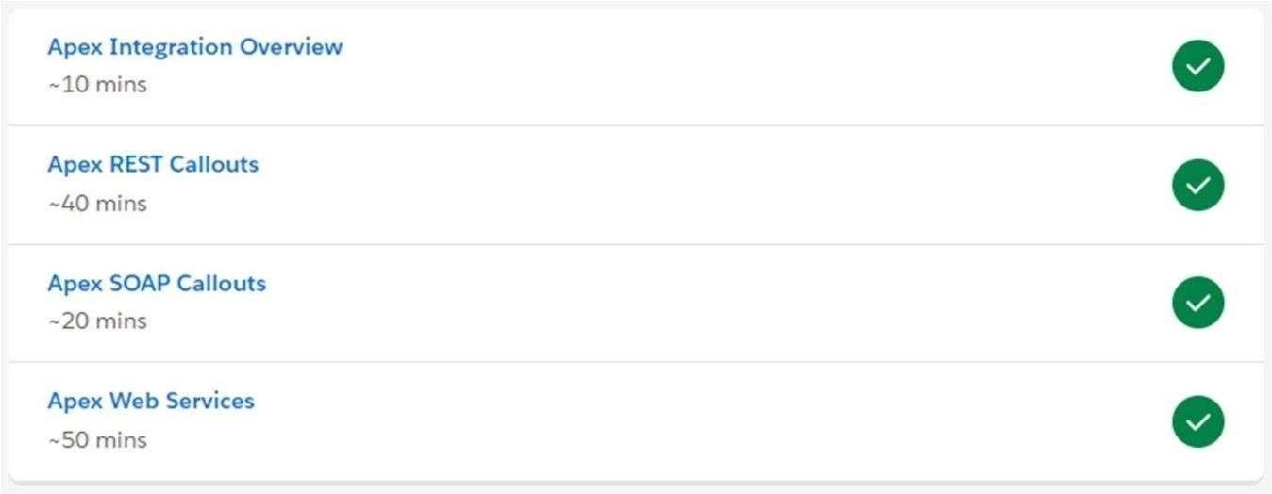

### CHAPTER 16: Project / Super Badges

The learner's journey is structured in such a way that, after completion of the live sessions and all trailhead courses modules, the Super Badges are unlocked automatically. The Learnerwhochoosesdeveloper as his/her learning path, needsto completethefollowing SuperBadges.

Apex Specialist:

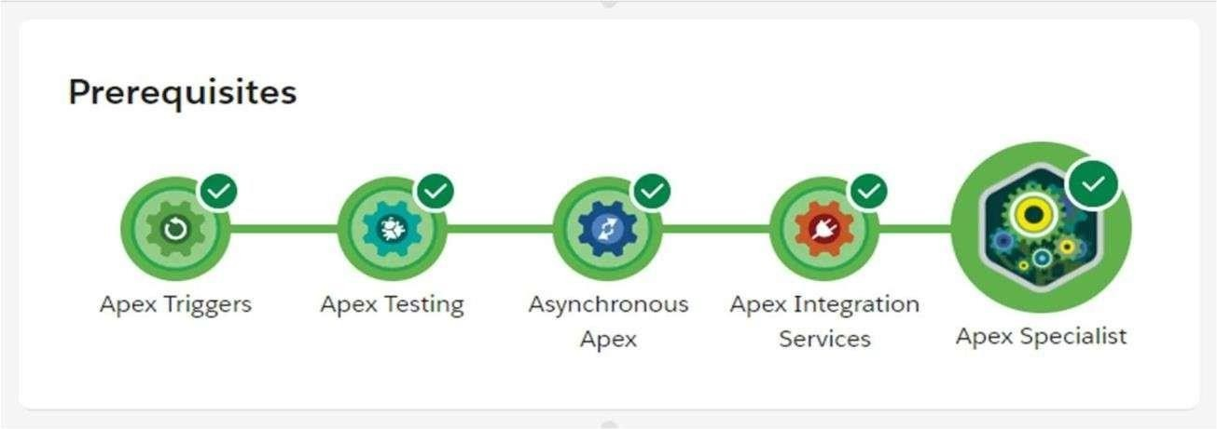

**What You'll Be Doing to Earn This Super badge:**

1. Automate record creation using Apex triggers
2. Synchronize Salesforce data with an external system using asynchronous REST callouts
3. Schedule synchronization using Apex code
4. Test automation logic to confirm Apex trigger side effects
5. Test integration logic using callout mocks
6. Test scheduling logic to confirm action gets queued

Concepts Tested in This Super badge:

* Apex Triggers
* Asynchronous Apex
* Apex Integration
* Apex Testing

**Pre-work and Notes**

**Set Up Development Org Use Case**

**Standard Objects**

**You’ll be working with the following standard objects:**

* **Maintenance Request (renamed Case)** — Service requests for broken vehicles, malfunctions, and routine maintenance.
* **Equipment (renamed Product)** — Parts and items in the warehouse used to fix or maintain RVs.

Custom Objects

* Vehicle — Vehicles in HowWeRoll’s rental fleet.
* Equipment Maintenance Item — Joins an Equipment record with a Maintenance Request record, indicating the equipment needed for the maintenance request.

Entity Diagram



**Business Requirements:**

This section represents the culmination of your meetings with key HowWeRoll stakeholders. It’s your blueprint to programmatically automate the support and

maintenance side of their business.

Follow the following steps to complete the super badge:

1. Automate Maintenance Requests
2. Synchronize Inventory Management
3. Create Unit Tests

Ensure that your code operates as expected in the scheduled context by validating that it executes after Test.stopTest() without exception. Also assert that a scheduled asynchronous job is in the queue. The test classes for the callout service and scheduled test must also have 100% test coverage.

ProcessAutomation Specialist:

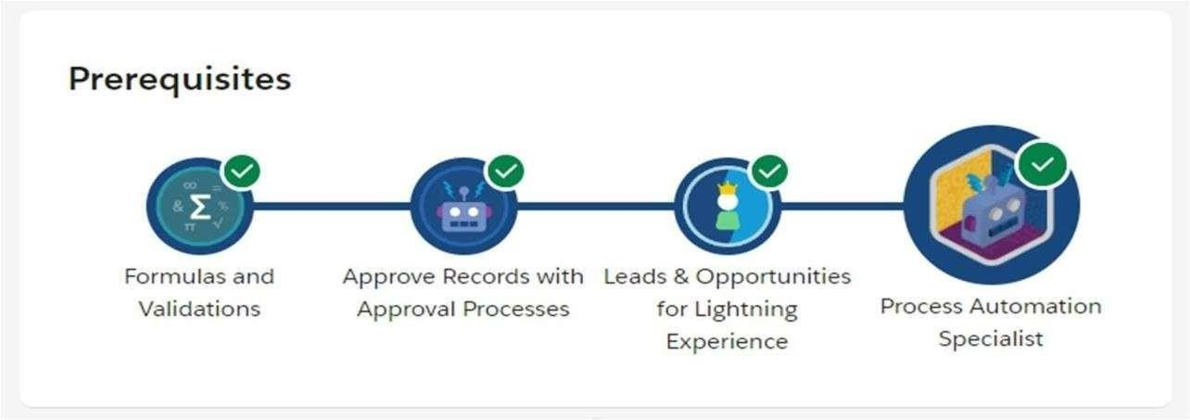

**What You'll Be Doing to Earn This Super badge:**

* 1. Automate lead ownership using assignment rules
  2. Enforce data integrity with formula fields and validation rules
  3. Create a custom object in a master-detail relationship to a standard object
  4. Define an opportunity sales process using stages, record types, and validation rules
  5. Automate business processes to send emails, create related records, and submit opportunities for approval
  6. Create a flow to display dynamic information on a Lightning record page
  7. Create a process to evaluate and update records

Concepts Tested in This Super badge

* Validations and Formulas
* Sales Process
* Process Builder ·
* Flow

**Pre-work and Notes Use Case Standard Objects**

**Custom Objects Business Requirements**

## CHAPTER 17: EXECUTIVE SUMMARY

This report is about our 8 weeks internship program with SmartInternz. In this comprehensive report, I have discussed about every major aspect of the company which I observed and perceived during my internship program.

During my internship program, we have learned and mainly worked on Trailhead Community. All the details have been discussed in detail. All the policies and procedures of the company have been discussed in detail.

As the main purpose of the internship is to learn by working in practical environment and to apply the knowledge acquired during the studies in real world scenario in order to tackle the problems using the knowledge and skill learned during the academic process.

#### CHAPTER 18: ABOUT THE COMPANY

SmartInternz, is an private Experiential Learning & Remote Externship Platform to bring academia & industry very close for a common goal of talent creation. To promote aid and faster the growth of micro, small and medium enterprises in the country. SmartInternz operates through countrywide network of offices and Technical Centers in the Country. In addition, SmartInternz has set up Training cum Incubation Centre managed by professional manpower.

**Mission:** “To promote and support Micro, Small & Medium

Enterprises (MSMEs) Sector” by providing integrated support services encompassing Marketing, Technology, Finance and other services.

**Vision:** “To be a premier Organization fostering the growth of Micro, Small and Medium Enterprises (MSMEs) Sector”.

## CHAPTER 19: OPPORTUNITIES

During these 8 weeks of the internship, we were given the opportunity to perform the following role:

##### Intern:

* Coordinating with the team members and team leads on a regular basis to keep a track of the activities like the meetings held and about the work to be done.
* I learned about developing the applications using different tools.
* For that I have referred the YouTube related to gain the complete knowledge on that.
* Then I have gathered the requirements.
* They also provide us the opportunity to voluntarily interact in other projects as well.
* They have given different tasks to develop different parts of the application.
* Also they have finally conducted some tests to certify with the completion of internship.

#### CHAPTER 20: TRAINING

In these 8 weeks of the training, they have provided us the training in Salesforce using different tools.

They have provided us with the training of several technologies like:

APEX:

Apex enables developers to access the Salesforce platform back-end database and client-server interfaces to create third-party SaaS applications. Apex includes an application programming interface (API) that Salesforce developers can use to access user data on the platform.

1. Integrated. Apex has built in support for DML operations like INSERT, DELETE and also DML Exception handling.
2. Strongly integrated with data.
3. Strongly typed.
4. Multitenant Environment.
5. Easy Testing.
6. Apex Applications.

JAVA:

Java is flexible language to use in app development. The required code is developed by using java.

1. Project Setup. Creating a Java Class Library Project.
2. Creating and Editing Java Source Code. Creating a Java Package and Class File.
3. Compiling and Running the Application.
4. Testing and Debugging the Application.
5. Building, Running, and Distributing the Application.

#### CHAPTER 21: CHALLENGES FACED

1. At the beginning of internship, I faced difficulty for understanding the applications and different tools.
2. I faced difficulty in the completion of Super Badges like Apex Specialists and Process Automation Specialists.
3. I faced difficulty in managing college and internship timings.
4. I faced difficulty in understanding the advanced topics in Apex.
5. I faced difficulty to create and run modules in different playgrounds.
6. I faced difficulty in managing the memory in pc.
7. Even with these difficulties, I am able to complete the internship and it helps me in securing a new job.